Multi-functions LAN Tester

DSS-CABLE-TESTER︱Cable test and cable tracer
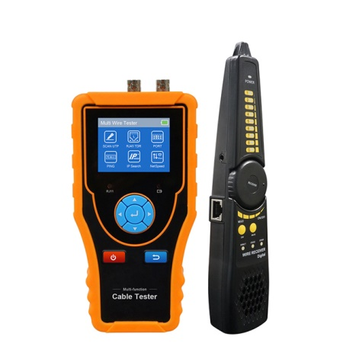
Multifunction LAN Tester
● 2.4 inch TFT-LCD screen, 320x240 resolution
● Cable tracer, can search UTP cable, BNC cable from mess cable
● Port Flash, PING test, IP address Scan, Link Monitor, etc
● RJ45 cable TDR test, cable quality test
● UTP cable test, test cable’s sequence, type and remote kit
● Can detect TVI, CVI, AHD, CVBS video signal peak value, SYNV value and and burst value

Application

The multifunction LAN tester is designed for maintenance and installation of cable, cable tracer, and HD Coaxial video level meter test in one equipment. The unit supports detect the near-end, mid-end and far-end fault point of RJ45 cable connector, and also supports Port Flash, PING test, IP address Scan, Link Monitor. Installers and engineers take the all in one cable tester, making working conditions safer and increasing productivity.

● Network cabling project installation and maintenance
● Computer room detection and maintenance
● CCTV system installation

Features

● 2.4 inch TFT-LCD screen, 320x240 resolution
● Secondary code digital mode, decisively rejects noise and false signals, locate cables quickly and easily.
● Advanced UTP cable test, test UTP cable's sequence, type and remote kit, quickly detect the near-end, mid-end and far-end fault point of RJ45 cable connector.
● RJ45 cable TDR test, test cable quality, length and attenuation.
● HD Coaxial video level meter, can detect the TVI/CVI/AHD/CVBS signal peak value, SYNC value and burst value.
● Port Flash, can search the switch port which connect the meter.
● PING test, check whether IP camera or other network equipment’s Ethernet port is working normally, the IP address whether is correct.
● IP Scan, quickly find the IP address of the IP camera or other network equipment which connected to the meter.
● Link status, quickly identify the connected network port (10/100/ 1000M) and duplex mode (full duplex / half duplex)
● 3.7 V /2000mAh Lithium Ion Battery, after 3 hours charging, working time lasts 16 hour

Specifications

LCD | Item series | DSS-CABLE-TESTER
LCD | Display | 2.4 inch TFT-LCD screen , 320x240 resolution
Cable test and cable tracer | UTP cable test | Test UTP cable's sequence, type and remote kit, quickly detect the near-end, mid-end and far-end fault point of RJ45 cable connector
Cable test and cable tracer | Cable type | RJ45 Twisted pair, RJ11 telephone line, BNC cable etc.
Cable test and cable tracer | The fault of RJ45 cable connector | Can determine the fault point of RJ45 cable connector from LOCAL/Remote indicator light
RJ45 TDR cable test | Test cable pair status, length, attenuation, reflectivity, impedance, skew etc. measurement range 180M.
Port flashing | Can search the Ethernet switch port which connect the meter
PING test | Check whether IP camera or other network equipment’s Ethernet port is working normally, the IP address whether is correct.
IP Scan | Quickly find the IP address of the IP camera or other network equipment which connected to the meter
Link Monitor | Quickly identify the connected network port (10/100/ 1000M) and duplex mode (full duplex / half duplex).
External power supply | DC 5V/1A
Battery | Built-in 3.7V Lithium Ion battery, 2000mAh. The cable Receiver battery: two AA batteries
Rechargeable | After charging 3 hours, normal working time 16 hours
Auto off | 1-30 (mins)
Working Temperature | -10℃---+50℃
Working Humidity | 30%-90%
Dimension/Weight | 126mm x 83mm x 33mm / 0.32kg
The data above is only for reference and any change of them will not be informed in advance. For more detailed technical inquiries, please feel free to contact us.

Packing kits

- LAN Tester
- Cable tracer
- Adaptor DC5V/1A
- Lithium ion battery (3.7V DC2000mAh)
- Tool bag / BNC cable/ Crocodile clip cable
- User manual

